A title should be the fewest possible words that accurately describe the content of the paper, no more than 16 words (Sentence case, left, bold, 14pt)

Author 1*, Author 2, Author 3, Author 4, Author 5 ←(11pt, bold, maximum consisting of 5 authors)
¹Name of University, Country ←10pt, Times New Roman
²Name of University, Country ←10pt, Times New Roman
³Name of University, Country ←10pt, Times New Roman
⁴Name of University, Country ←10pt, Times New Roman
⁵Name of University, Country ←10pt, Times New Roman
¹author@author.com*, ²author@author.com, ³author@author.com, ⁴author@author.com, ⁵author@author.com
Article Info |  | ABSTRACT
Article history:  Received DDMMYY  Revised DDMMYY  Accepted DDMMYY |  | A well-prepared abstract allows readers to quickly and accurately identify the basic content of a document, determine its relevance to their interests, and thereby decide whether to read the document in its entirety. The abstract must be informative and clear enough, written clearly, and provide a clear statement of the problem, research objectives, research methods, findings, and conclusions. Abstracts should consist of 100 to 200 words. The abstract must be written in the past tense. Standard nomenclature should be used, and abbreviations should be avoided. No literature may be cited. Keyword lists provide the opportunity to add keywords used by indexing and abstracting services in addition to the keywords already present in the title. Wise use of keywords can increase the ease with which interested parties find our articles (9 pt).
Keyword:
The first keyword; the second keyword; the third keyword; The fourth keyword; The fifth keywords. (There are a minimum of five keywords and a maximum of six keywords)

©2024 Authors. Published by Astu Publishing. This work is licensed under a Creative Commons Attribution-NonCommercial 4.0 International License.
(https://creativecommons.org/licenses/by-nc/4.0/)

INTRODUCTION (Capital, bold , Times new romance 11 pt)
This section explains the three main components. First, to describe the phenomenon being studied, the introduction must contain the research background and research context. Second, the author explains the relationship between the phenomenon and existing theories (at least the journal cited must be less than ten years old), along with gap analysis and the novelty of the research, and finally explains the research objectives. All introductions should be presented in paragraph form, not pointers, with a proportion of 15-20% of the overall length of the article.
The introduction should not be divided into background sub-chapters, problem formulation, and objectives. Beginning of paragraph once tab. Citations are written in bodynote format and are relevant to the bibliography (recommended using the Mendeley application or other reference management application programs such as EndNote, Reference Manager, or Zotero) (10pt, spacing 1.0, spacing after paragraph 6pt).
The manuscript should be written as concisely, consistently, and as directly as possible. The number of pages consists of 10–20 (twenty) pages (including figures and tables). Manuscripts are written single-spaced on one side of A4-sized paper (210 x 297 mm). Manuscripts must have normal margins, or top, bottom, right, and left margins, namely 2.54 cm. The font used is Times New Roman. 10pt. Manuscripts must be written in English.

RESEARCH METHODS (Capital, bold , Times new romance 11 pt)
The Methods section must be short but must include sufficient technical information and contain the type of research, research population, research samples or subjects, and data analysis techniques. Only new methods have to be described in detail. Cite previously published procedures in References.

RESULTS AND DISCUSSION (Capital, bold , Times new romance 11 pt)
Results should include the rationale or design of the experiment as well as the results of the experiment. Results can be presented in the form of images, tables, and text. Research findings must be supported by adequate data. This section must answer the research hypothesis.
The discussion should be an interpretation of the results, not a repetition of the results. This discussion includes at least: an explanation of the meaning of the findings and why the findings are important; Support the answer with the results. Explain how your results relate to expectations and the literature; state clearly why the results are acceptable and whether there is any agreement or conflict with previous research results; consider alternative explanations for the findings; consider research implications; study limitations; and provide suggestions for further research.
Avoid writing in the form of bullet numbering or item list style; it is best to write it in the form of a descriptive paragraph, even though it is a list item. If it contains tables and figures, the numbering is a continuation of the previous number. Each table and figure must be given a title.

Table
The table is in the middle. Use Times New Roman and font sizes 8 to 11. Horizontal lines in the middle of the table do not need to be displayed; only display the heading and the very end, and there should also be no vertical lines. Make sure you create the table correctly via the Insert Table menu. Tables should be referenced in the text by writing something like: '... (Tables are written with a capital 'T').
Table 1. Title Of The Table
(Capitalize Each Words and bold)
No. | This line
1 | This table contents, if not enough, you can reduce the font size to 8 points. Don't go any smaller than this, unless you want your readers to hurt your eyes. :-) | Regular table fill font

Try not to truncate the table on different pages unless the size exceeds one page. If you have to truncate, don't forget to rewrite the header row for each column, given the same table serial number, and replace the title with Continuation. The table title does not end with a period. Tables do not need to use vertical lines.

Figure
As with tables, make sure each figure has a sequence number and a title. Make the images you use to look like they're professionally made and don't need to be framed. It is better to use black-and-white images

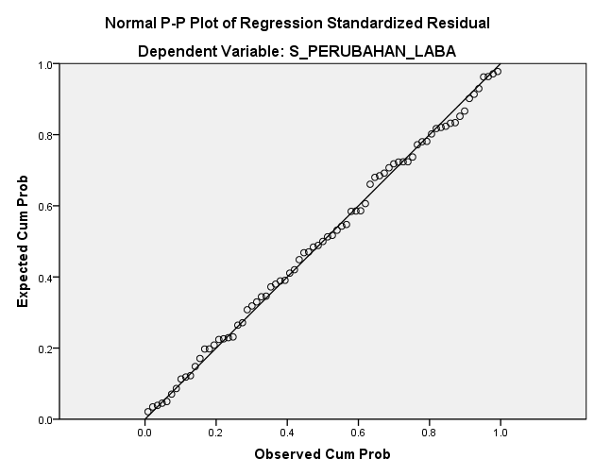
Figure 1. The title of the image
(also uses Capitalize Each Words, bold)

CONCLUSION (Capital, bold , Times new romance 11 pt)
The conclusion must contain confirmation of the problems that have been analyzed in the results and discussion sections. Write a conclusion concisely and clearly. It is not recommended that the conclusion be written in several parts or points. The conclusion is intended to help readers understand why your research is important to them after they have finished reading the manuscript. A conclusion is not simply a summary of the main topics discussed or a restatement of your research problem, but rather a synthesis of the important points. It is important that the conclusion does not leave any questions unanswered.

REFERENCES (Capital, bold , Times new romance 11 pt)
Written using the style of the American Psychological Association 7th edition, 80% of references must be primary sources, references from the last 10 years, and it is recommended to use the Mendeley application or other reference management application programs such as EndNote, Reference Manager, or Zotero. The bibliography does not need to be divided into sections. The minimum number of references in the bibliography is 15 references. The following is an example of bibliography writing:
Book :
Creswell, J. W., & Poth, C. N. (2016). Qualitative inquiry and research design: Choosing among five approaches. Sage publications.
Journal with DOI :
Chick, R. C., Clifton, G. T., Peace, K. M., Propper, B. W., Hale, D. F., Alseidi, A. A., & Vreeland, T. J. (2020). Using technology to maintain the education of residents during the COVID-19 pandemic. Journal of surgical education, 77(4), 729-732. https://doi.org/10.1016/j.jsurg.2020.03.018
Journal without DOI :
Halili, S. H. (2019). Technological advancements in education 4.0. The Online Journal of Distance Education and e-Learning, 7(1), 63-69. https://tojdel.net/journals/tojdel/volumes/tojdel-volume07-i01.pdf#page=70
Dictionary/Encyclopedia – print :
VandenBos, G. R. (Ed.). (2017). APA dictionary of psychology. Washington, DC: American Psychological Association.

Dictionary/Encyclopedia – online :
Arcus, D. (2016). Attention deficit / hyperactivity disorder (ADHD). In B. Strickland (Ed.), The Gale encyclopedia of psychology. http://www.gale.cengage.com/
Conference/Seminar paper in published proceedings – print :
Edge, M. (2016). Lifetime prediction: Fact or fancy? In M. S. Koch, T. Padfield, J. S. Johnsen, & U. B. Kejser (Eds.), Proceedings of the Conference on Research Techniques in Photographic Conservation (pp. 97-100). Copenhagen, Denmark: Royal Danish Academy of Fine Arts.
Conference/Seminar paper in published proceedings – online :
Tester, J. W. (2018). The future of geothermal energy as a major global energy supplier. In H. Gurgenci & A. R. Budd (Eds.), Proceedings of the Sir Mark Oliphant International Frontiers of Science and Technology Australian Geothermal Energy Conference, Canberra, Australia: Geoscience Australia. http://www.ga.gov.au/image_cache/GA11825.pdf
Thesis, or Dissertation:
Anjarwati, K., Chabachib, M., & Pengestuti, I. D. (2016). Pengaruh profitabilitas, size, dan likuiditas terhadap nilai perusahaan manufaktur di Indonesia dengan struktur modal sebagai variabel intervening studi empiris pada perusahaan manufaktur yang terdaftar di Bursa Efek Indonesia tahun 2012-2015 (Thesis). Diponegoro University. http://eprints.undip.ac.id/51133/

